MACH4METAL

metalworking machinery
Transito 21,
6909 DA BABBERICH
Netherlands
Tel. +31 (0)316 – 247123
Fax. +31 (0)316 - 247956
info@mach4metal.com
www.mach4metal.com

Bank No : 66.52.13.883
IBAN : NL33 INGB 0665 2138 83
BIC : INGBNL2A

PEMA Self Aligning Rotator 60 tons
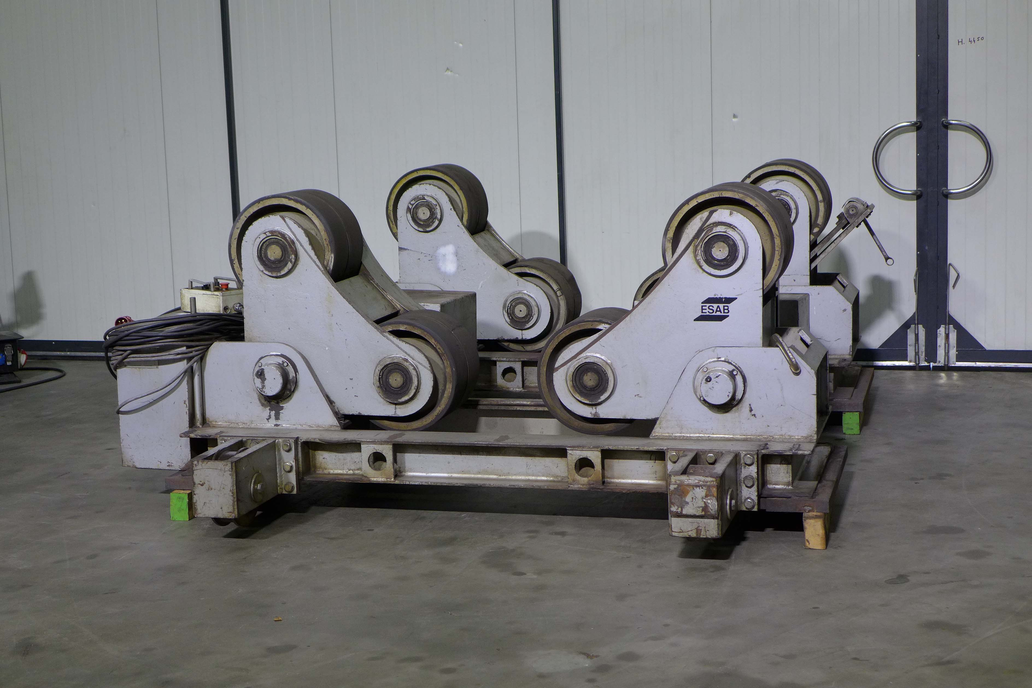
- Make : ESAB PEMA
- Typ : 60TS
- Mach.No. : C 5083
- Age : 04 . 1997

- Drive capacity : 60 T
- Load capacity per section : 30 T

- Vessel Ø range Minimum : 900
- Vessel Ø range Maximum : 4.500
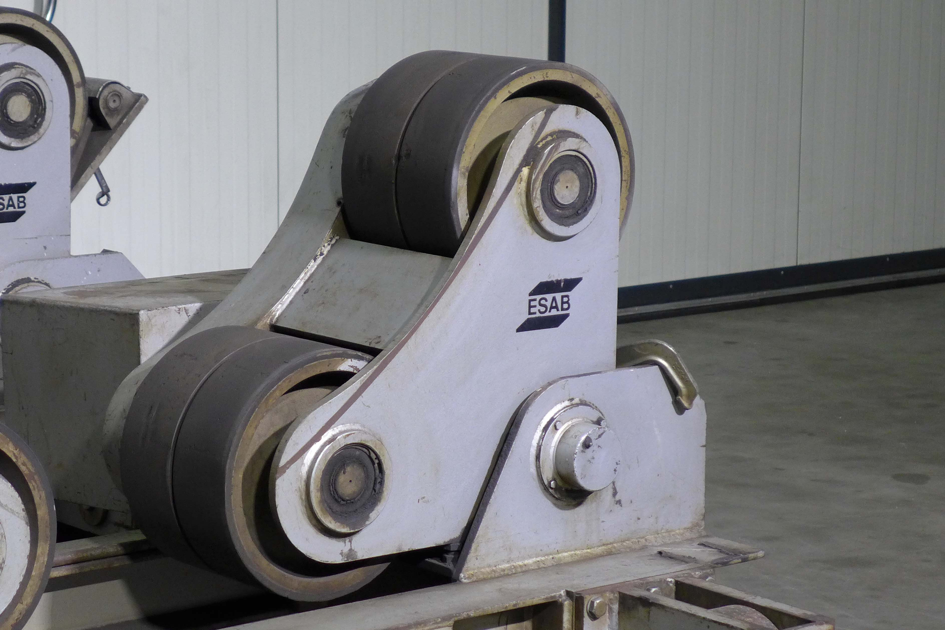

- Speed range variable min : 90
- Speed range variable max : 1.200

- No of wheels per section: 4

- Dimensions Drive Idler
- Length 3.220 2.790
- Width 1.120 700
- Weight 2.600 1.900

Self aligned rotator permit the rollers to align themselves to the workpiece without the need for manual pre-adjustment irrespective of ovality or regularity

Please Note: The above information has been obtained to the best of our ability and belief from, and from the manufacturers where possible. It is given in good faith, but its accuracy can not be guaranteed. Accordingly, it will not form a representation or constitute contractual terms. We advise you to check any vital details!

